Correctness of the OO Program

No of test cases: 10

No of test cases Passed: 10

QA Status: PASS

Screenshot:

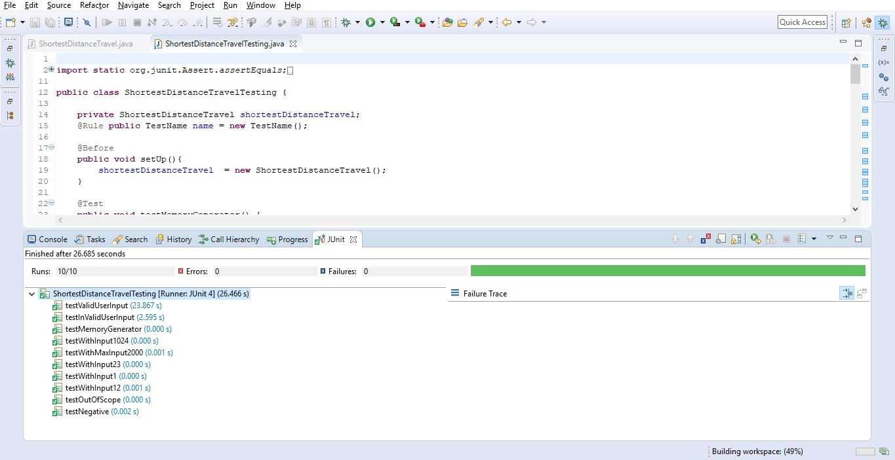

Console:

Started executing testValidUserInput

23

Shortest distance travel to reach square 1 is 2

Execution completed for testValidUserInput

Started executing testInValidUserInput

Asdfa

Test Case Started for testWithInput 1024

Shortest distance travel to reach square 1 is 31

Test Case completed for testWithInput1024

Test Case Started for testWithMaxInput2000

Shortest distance travel to reach square 1 is 25

Test Case completed for testWithMaxInput2000

Test Case Started for testWithInput23

Shortest distance travel to reach square 1 is 2

Test Case completed for testWithInput23

Test Case Started for testWithInput1

Shortest distance travel to reach square 1 is 0

Test Case completed for testWithInput1

Test Case Started for testWithInput12

Shortest distance travel to reach square 1 is 3

Test Case completed for testWithInput12

Started executing testNegative

Invalid Entry, Try again

Execution completed for testNegative

Started executing testNegative

Invalid Entry, Try again

Execution completed for testNegative